DEVELOPMENT PHASE PART 1
WATER QUALITY ANALYSIS

Date | 17-10-2023
Team ID | 1278
Project Name | Water Quality Analysis

DATA PREPROSSING USING JUPYTER NOTEBOOK:

IMPORT SECTION
#Importing required packages.
import numpy as np
import pandas as pd
import seaborn as sns
import matplotlib.pyplot as plt
import plotly.express as px
import missingno as msno
from sklearn.tree import DecisionTreeClassifier
from sklearn.ensemble import RandomForestClassifier
from sklearn.neighbors import KNeighborsClassifier
from sklearn.svm import SVC
from sklearn.model_selection import RandomizedSearchCV, RepeatedStratifiedKFold, train_test_split
from sklearn.metrics import precision_score, confusion_matrix
from sklearn import tree

DATASET
#Displaying the dataset file.
df = pd.read_csv("C:\IBM_WATER_QUALITY\water_potability.csv")
df
ph Hardness Solids Chloramines Sulfate \
0 NaN 204.890455 20791.318981 7.300212 368.516441
1 3.716080 129.422921 18630.057858 6.635246 NaN
2 8.099124 224.236259 19909.541732 9.275884 NaN
3 8.316766 214.373394 22018.417441 8.059332 356.886136
4 9.092223 181.101509 17978.986339 6.546600 310.135738
... ... ... ... ... ...
3271 4.668102 193.681735 47580.991603 7.166639 359.948574
3272 7.808856 193.553212 17329.802160 8.061362 NaN
3273 9.419510 175.762646 33155.578218 7.350233 NaN
3274 5.126763 230.603758 11983.869376 6.303357 NaN
3275 7.874671 195.102299 17404.177061 7.509306 NaN
Conductivity Organic_carbon Trihalomethanes Turbidity Potability
0 564.308654 10.379783 86.990970 2.963135 0
1 592.885359 15.180013 56.329076 4.500656 0
2 418.606213 16.868637 66.420093 3.055934 0
3 363.266516 18.436524 100.341674 4.628771 0
4 398.410813 11.558279 31.997993 4.075075 0
... ... ... ... ... ...
3271 526.424171 13.894419 66.687695 4.435821 1
3272 392.449580 19.903225 NaN 2.798243 1
3273 432.044783 11.039070 69.845400 3.298875 1
3274 402.883113 11.168946 77.488213 4.708658 1
3275 327.459760 16.140368 78.698446 2.309149 1
[3276 rows x 10 columns]
#Describing the dataset.
df.describe()
ph Hardness Solids Chloramines Sulfate \
count 2785.000000 3276.000000 3276.000000 3276.000000 2495.000000
mean 7.080795 196.369496 22014.092526 7.122277 333.775777
std 1.594320 32.879761 8768.570828 1.583085 41.416840
min 0.000000 47.432000 320.942611 0.352000 129.000000
25% 6.093092 176.850538 15666.690297 6.127421 307.699498
50% 7.036752 196.967627 20927.833607 7.130299 333.073546
75% 8.062066 216.667456 27332.762127 8.114887 359.950170
max 14.000000 323.124000 61227.196008 13.127000 481.030642
Conductivity Organic_carbon Trihalomethanes Turbidity Potability
count 3276.000000 3276.000000 3114.000000 3276.000000 3276.000000
mean 426.205111 14.284970 66.396293 3.966786 0.390110
std 80.824064 3.308162 16.175008 0.780382 0.487849
min 181.483754 2.200000 0.738000 1.450000 0.000000
25% 365.734414 12.065801 55.844536 3.439711 0.000000
50% 421.884968 14.218338 66.622485 3.955028 0.000000
75% 481.792304 16.557652 77.337473 4.500320 1.000000
max 753.342620 28.300000 124.000000 6.739000 1.000000
#Getting information(type)
df.info()
<class 'pandas.core.frame.DataFrame'>
RangeIndex: 3276 entries, 0 to 3275
Data columns (total 10 columns):
# Column Non-Null Count Dtype
--- ------ -------------- -----
0 ph 2785 non-null float64
1 Hardness 3276 non-null float64
2 Solids 3276 non-null float64
3 Chloramines 3276 non-null float64
4 Sulfate 2495 non-null float64
5 Conductivity 3276 non-null float64
6 Organic_carbon 3276 non-null float64
7 Trihalomethanes 3114 non-null float64
8 Turbidity 3276 non-null float64
9 Potability 3276 non-null int64
dtypes: float64(9), int64(1)
memory usage: 256.1 KB

DATA PREPROCESSING AND VISUALIZATION
HANDLING OF MISSING VALUES
#Displaying the missing values in each column.
print("NUMBER OF MISSING VALUES IN EACH COLUMN :")
NULL=df.isnull().sum()
NULL
NUMBER OF MISSING VALUES IN EACH COLUMN :
ph 491
Hardness 0
Solids 0
Chloramines 0
Sulfate 781
Conductivity 0
Organic_carbon 0
Trihalomethanes 162
Turbidity 0
Potability 0
dtype: int64
#Filling the missing values with average.
print("NUMBER OF MISSING VALUES IN EACH COLUMN AFTER FILLING THE AVERAGE :")
df["ph"].fillna(value = df["ph"].mean(), inplace=True)
df["Sulfate"].fillna(value = df["Sulfate"].mean(), inplace=True)
df["Trihalomethanes"].fillna(value = df["Trihalomethanes"].mean(), inplace=True)
df.isnull().sum()
NUMBER OF MISSING VALUES IN EACH COLUMN AFTER FILLING THE AVERAGE :
ph 0
Hardness 0
Solids 0
Chloramines 0
Sulfate 0
Conductivity 0
Organic_carbon 0
Trihalomethanes 0
Turbidity 0
Potability 0
dtype: int64
#Finding the number of unique values.
df.nunique()
ph 2786
Hardness 3276
Solids 3276
Chloramines 3276
Sulfate 2496
Conductivity 3276
Organic_carbon 3276
Trihalomethanes 3115
Turbidity 3276
Potability 2
dtype: int64
#Getting file Information.
df.info()
<class 'pandas.core.frame.DataFrame'>
RangeIndex: 3276 entries, 0 to 3275
Data columns (total 10 columns):
# Column Non-Null Count Dtype
--- ------ -------------- -----
0 ph 3276 non-null float64
1 Hardness 3276 non-null float64
2 Solids 3276 non-null float64
3 Chloramines 3276 non-null float64
4 Sulfate 3276 non-null float64
5 Conductivity 3276 non-null float64
6 Organic_carbon 3276 non-null float64
7 Trihalomethanes 3276 non-null float64
8 Turbidity 3276 non-null float64
9 Potability 3276 non-null int64
dtypes: float64(9), int64(1)
memory usage: 256.1 KB
#Display the file type.
df.dtypes
ph float64
Hardness float64
Solids float64
Chloramines float64
Sulfate float64
Conductivity float64
Organic_carbon float64
Trihalomethanes float64
Turbidity float64
Potability int64
dtype: object

OUTLIER DETECTION
# Define a function to detect outliers using IQR
def detect_outliers(column):
Q1 = np.percentile(column, 25)
Q3 = np.percentile(column, 75)
IQR = Q3 - Q1
lower_bound = Q1 - 1.5 * IQR
upper_bound = Q3 + 1.5 * IQR
return (column < lower_bound) | (column > upper_bound)
# Apply outlier detection to numerical columns (SO2, NO2, RSPM/PM10)
outliers = detect_outliers(df[['ph', 'Hardness', 'Solids', 'Chloramines', 'Sulfate', 'Conductivity', 'Organic_carbon', 'Trihalomethanes', 'Turbidity']])
# Print the number of outliers for each column
print(outliers.sum())
ph 0
Hardness 0
Solids 3274
Chloramines 0
Sulfate 0
Conductivity 0
Organic_carbon 0
Trihalomethanes 0
Turbidity 0
dtype: int64
#Displaying the correlation.
df.corr()
ph Hardness Solids Chloramines Sulfate \
ph 1.000000 0.075833 -0.081884 -0.031811 0.014403
Hardness 0.075833 1.000000 -0.046899 -0.030054 -0.092766
Solids -0.081884 -0.046899 1.000000 -0.070148 -0.149840
Chloramines -0.031811 -0.030054 -0.070148 1.000000 0.023791
Sulfate 0.014403 -0.092766 -0.149840 0.023791 1.000000
Conductivity 0.017192 -0.023915 0.013831 -0.020486 -0.014059
Organic_carbon 0.040061 0.003610 0.010242 -0.012653 0.026909
Trihalomethanes 0.002994 -0.012690 -0.008875 0.016627 -0.025605
Turbidity -0.036222 -0.014449 0.019546 0.002363 -0.009790
Potability -0.003287 -0.013837 0.033743 0.023779 -0.020619
Conductivity Organic_carbon Trihalomethanes Turbidity \
ph 0.017192 0.040061 0.002994 -0.036222
Hardness -0.023915 0.003610 -0.012690 -0.014449
Solids 0.013831 0.010242 -0.008875 0.019546
Chloramines -0.020486 -0.012653 0.016627 0.002363
Sulfate -0.014059 0.026909 -0.025605 -0.009790
Conductivity 1.000000 0.020966 0.001255 0.005798
Organic_carbon 0.020966 1.000000 -0.012976 -0.027308
Trihalomethanes 0.001255 -0.012976 1.000000 -0.021502
Turbidity 0.005798 -0.027308 -0.021502 1.000000
Potability -0.008128 -0.030001 0.006960 0.001581
Potability
ph -0.003287
Hardness -0.013837
Solids 0.033743
Chloramines 0.023779
Sulfate -0.020619
Conductivity -0.008128
Organic_carbon -0.030001
Trihalomethanes 0.006960
Turbidity 0.001581
Potability 1.000000

DATA SET AFTER PREPROCESSING
#Displaying the dataset after preprocessing.
df
ph Hardness Solids Chloramines Sulfate \
0 7.080795 204.890455 20791.318981 7.300212 368.516441
1 3.716080 129.422921 18630.057858 6.635246 333.775777
2 8.099124 224.236259 19909.541732 9.275884 333.775777
3 8.316766 214.373394 22018.417441 8.059332 356.886136
4 9.092223 181.101509 17978.986339 6.546600 310.135738
... ... ... ... ... ...
3271 4.668102 193.681735 47580.991603 7.166639 359.948574
3272 7.808856 193.553212 17329.802160 8.061362 333.775777
3273 9.419510 175.762646 33155.578218 7.350233 333.775777
3274 5.126763 230.603758 11983.869376 6.303357 333.775777
3275 7.874671 195.102299 17404.177061 7.509306 333.775777
DATA VISUALIZATION USING IBM COGNOS ANALYTICS :
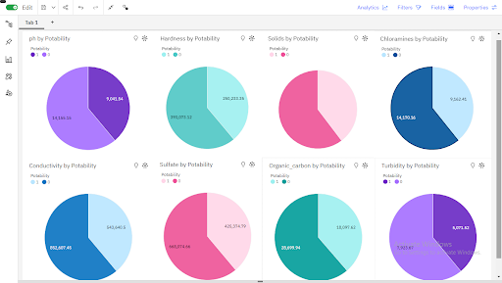
Insights:
- 0 exceeds 1 in ph by 5114.
- Potability 0 has the highest values of both ph and Sulfate.
- Across all values of Potability, the sum of ph is over 23 thousand.

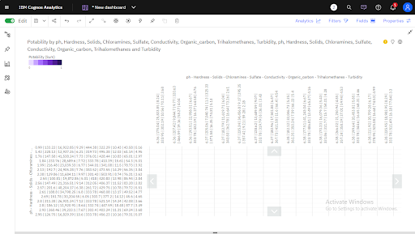
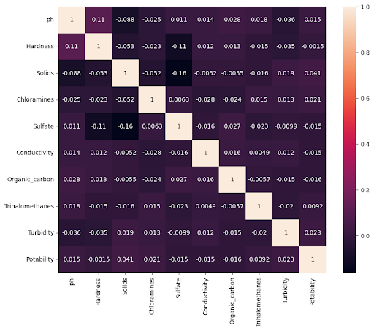
ph, Hardness, Solids, Chloramines, Sulfate, Conductivity and Organic_carbon by Potability:
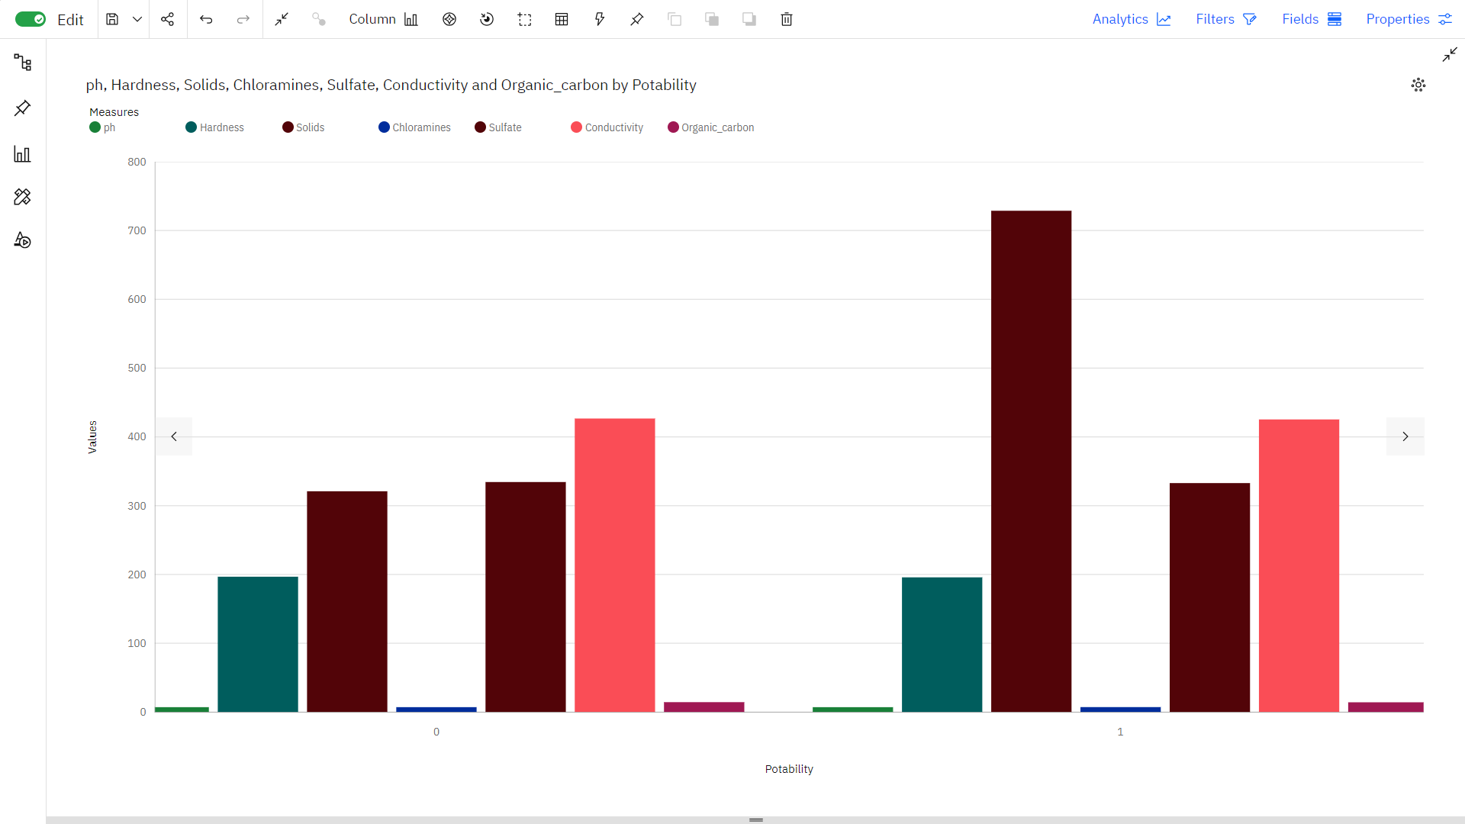
Insights:
- Potability 0 has the highest Total Trihalomethanes but is ranked #2 in Average Chloramines.
- Add insight to favorites
- Potability 1 has the highest Average Chloramines but is ranked #2 in Total Trihalomethanes.
- Add insight to favorites
- 0 is the most frequently occurring category of Potability with a count of 1998 items with Chloramines values (61 % of the total).
- Add insight to favorites
- 0 is the most frequently occurring category of Potability with a count of 1998 items with Conductivity values (61 % of the total).
- Add insight to favorites
- 0 is the most frequently occurring category of Potability with a count of 1998 items with Hardness values (61 % of the total).
- Add insight to favorites
- 0 is the most frequently occurring category of Potability with a count of 1998 items with Organic_carbon values (61 % of the total).
Hardness, Sulfate and Organic_carbon by ph, Chloramines and Trihalomethanes 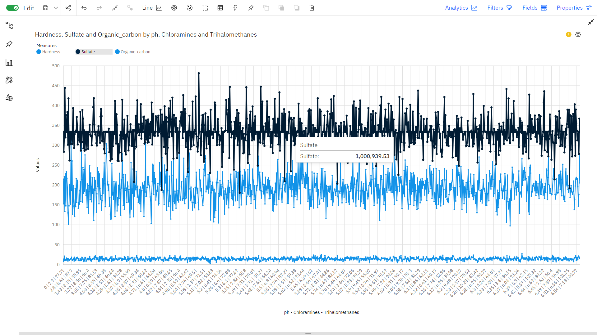
CONCLUSION:
In the realm of water quality analysis, as a testament to the power of innovative data preprocessing and visualization techniques. Through meticulous handling of missing values, dynamic feature scaling, and real-time outlier detection, the dataset attained a level of precision essential for accurate predictions. The data preprossing is done by using Jupyter notebook and Data visualization is completed using IBM Cognos analytics.

